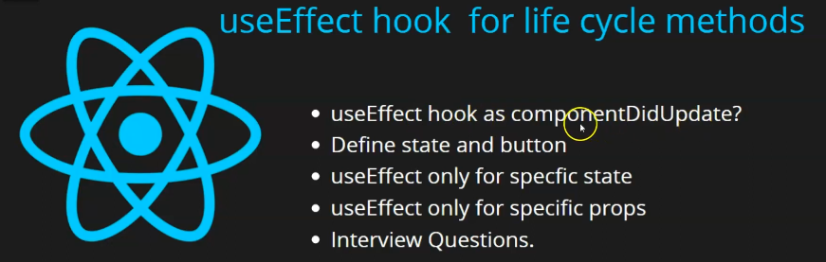

In this lesson we will know that how to use useEffect with updation of state and props in last lesson teacher told us that mounted that is initially get rendered and then mounted (who knows may be teacher is wrong) then how useEffect will work then teacher told us to use empty array there and then it will be mounted or rendered. Now question arise that suppose there are lots of state and props as well in your component when they will be updated then how you can use useEffect. Suppose you have 4 or 5 state or props and then in any two props or nay two state you want to call useEffect and don’t want to call on other state or props then what condition we will pass and how we will manage that and a very important question is asked that how can we use useEffect as componentDidUpdate. Now you can have question that what is the meaning of componentDidUpdate. Now as the teacher told us that initially we have class based component where we can use lifecycle methods Now to overcome them we made functional component and for lifecycle methods we start using useEffect in place of lifecycle methods then there was inside class based component a lifecycle method was there that was called componentDidUpdate it was used to call when there was any updation in your component’s state and props they could ask you interview question that in functional component how you can use useEffect on the updation of any props or state or how you can use it as a componentDidUpdate

Because both the question has the same answer then you will know it So first we will make a state and button and we will use useEffect with other states if you have three or four state but you want to call useEffect for one state or prop then how you can do it.

2:00

Not one useEffect how can we use multiple useEffect suppose you have one class (or component ) and you want to call three-four useEffect(who knows) then is it possible or not we will see it

So what will be the interview questions teacher tell it first hand

First will be how you can you use useEffect like componentDidUpdate

second thing is that can we use multiple useEffect in same component

third is how you can call useEffect for a specific state or prop see hoe many question are formed

Now firstly we are going to make a button in return of App.jsx and add title to it that is Update Counter we are taking this because for some ajeeb reason

We add a state of count with setCount method and give it initial value of 0.

And then we show it inside the text component and we add onPress on our button to handle its press event on it when the button is clicked then in callback setCount is called to update count variable and this new count variable has value 1 more than previous value Now our code will look like below

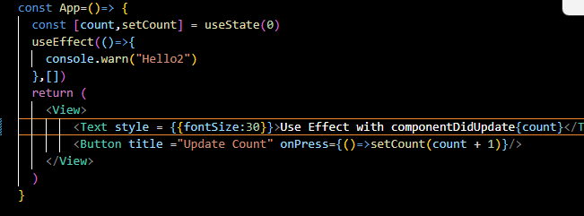

Now we click on update button and the number will be increased incremently as shoen below

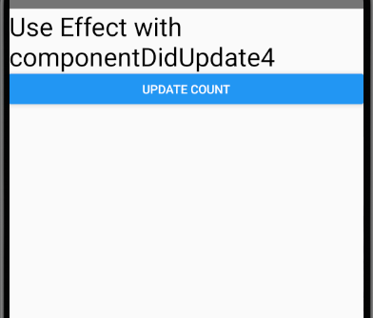

Our purpose is here to show how we can call hook on a specific state

SO we write useEffect here and then inside it we pass callback function and we print something

And in console.warn we print variable count

One thing to keep in mind that second parameter that we have studied in last lesson in which we told you how to use useEffect as componentDidMount and we told there t use it like componentDidMount then pass empty array in its second parameter but if you want to use it like componentDidUpdate then inside array( passed in second parameter ) pass any state that whenever this state will be updated then the useEffect will be called we pass count state now our code will look like below

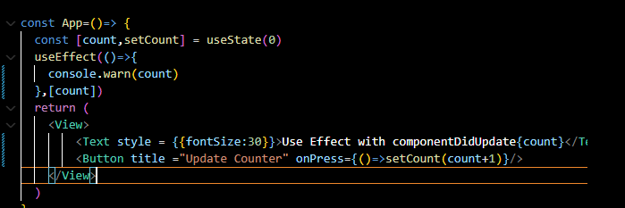

Now when we save our file then initially you will see 0 in the warning Now the question arises that as the teacher said that the useEffect will only be called when state we passed in the array in second parameter of useEffect ( in this case count) is updated then when we save our file then why did it work then it should not work because we did not update state then why when we save it then why did it work It is because initially state is updated weather you pass any array in second parameter of useEffect or not It is all about mount of component(who knows). So it just update the state when the app is loaded in memory Now when you click on the button then you will see the warning showing the subsequent number in the warning as shown below

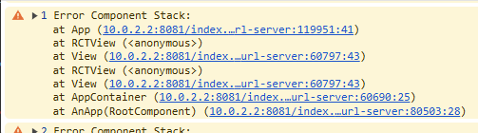

Now we have seen if we pass the state in the array of the useEffect passed as a second parameter of useEffect then on the base of it our useEffect will be called but there is one thing is not sure that if we have one more state then this useEffect would have worked or not

Now we take another button and we take another state and we name this state as data and then we use this setData method to update data state by default we keep the state data 100 and in starting of Text component print this data state as marked below

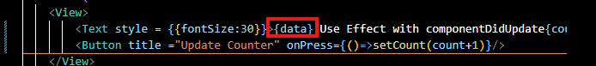

Now you can see in the output as well

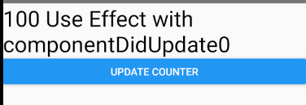

Now we setup the onPress of the New button

7:00

And then in the onPress callback update the data state same as we did with update Counter button

We make the second button title as Update data

Now our output screen will look like below

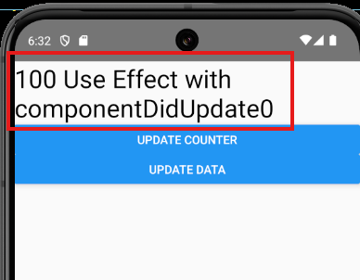

Now if we click on the update counter button then in the marked text the last number will be updated but the warning will be shown in the output screen means useEffect runs and in warning the score is shown but if we click on the Update Data button then first number will be incremented but no warning will be shown as useEffect was not run so no warning will be shown

That means in the state which we wanted to use useEffect on we have successfully done It

This is what we wanted, to run useEffect on the updation of the count variable and should not use useEffect on the updation of data

Now you will say what you did is that we have useEffect and call it for one state and does not call it for another state. What is the benefit of it Make it understand

Its benefit is that suppose if you update count and then on the basis of that want to perform an action or you want to apply logic . Suppose your counter is increasing and you want to check if counter become 100 then you call the function some animation, some API. Then you can write it under useEffect but suppose if we have not given any condition that is passed state in the array of second argument then what will happen that this counter will run in the cases then this useEffect would run in both of the cases Now warning will be called for both the buttons

Now what would have happened that the whatever work you want to do for the updation of count state then it would also work for data state that’s why we do that by passing count state in the array of second parameter in the useEffect So that the useEffect will run in the case of updation of count state not in the case of updation of data.

Now suppose if three was third more state and you want that this use Effect should run on two states bit not on third state. Now suppose there was other state that is name and age with count Now on whatever you want to useEffect on write their name separating their name by comma as shown below



for example if you don’t want to update the data state then don’t include it in the array

So basically we are telling on what state the useEffect should be called

Now suppose you want there should be another useEffect and there should be condition for data state in second argument

Now we naively replace the count with data as shown below



Now our useEffect for count is removed so then for that you can create another useEffect

We do something in useEffect as shown below

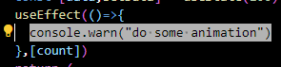

Now we are printing a message showing do some animation for count state

10:30

Now we create another useEffect and this time in second parameter we pass it and include it in the array and then print message “call some api here”

Now new useEffect will look like below



Now we have two useEffect in our component as marked below

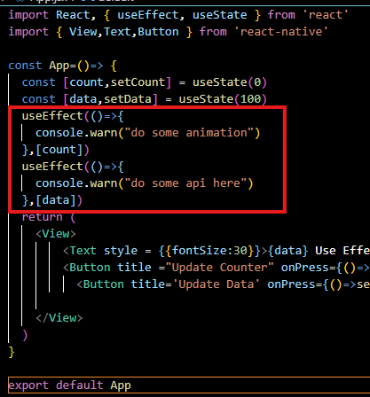

Now as we update count state by pressing the update counter button then in warning “do some animation” will be printed in the warning (wee see out from Teacher perspective So nwarning will not be shown in debugger this time bit on the bottom of the screen)

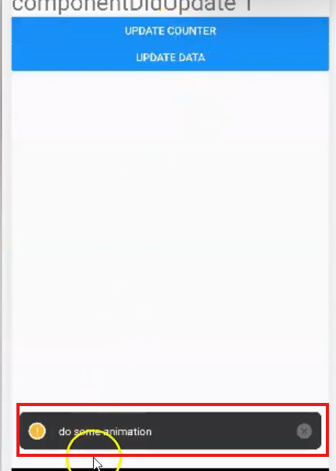

Now if we update the data state by clicking on Update Data button then in the warning “call some api here” will be printed as shown below( From Teacher POV)



So by this way you can use two useEffect inside the same component. Now here we talked about state. If we talk about props then how we will do it then it is very easy

To show it we make another file component in the same file

And now in return use some Text component we change its color to orange Now our newly made component look like below

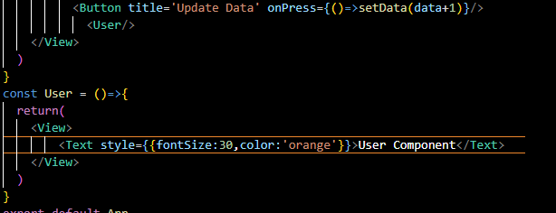

Now use it inside App component Now output will look like below

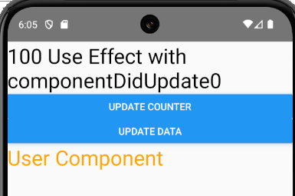

Now we add a useEffect inside the User component as shown below

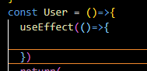

and we will pass state count and data(after storing in an project) to the User component as props as marked below

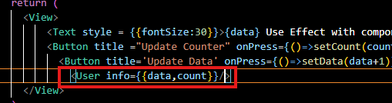

Now will access the prop and print it as shown below

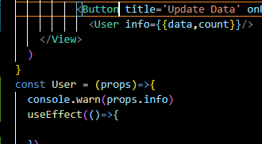

Teacher comment out the useEffect for count and data state as shown below so that we can see the warning or props

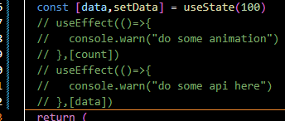

Now when we click on update data or count then we can se the changers in object shown in warning

That see the data or count property increasing incremently by clicking there respective button as shown below(ATT)

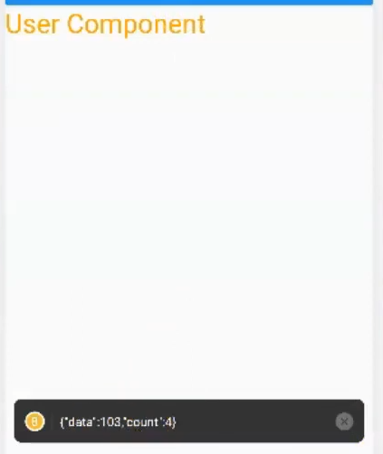

**Discovery:-**

I think when a state is changed then rerender happens and then after rerender useEffect is called(who knows)

Now in useEffect of User we print a warning that “run this code when data prop is updated”

Now we want that this should work data useEffect run after this but Teacher is saying that data useEffect will run ( I think he is wrong here )

Now we print the data and count prop on the screen as shown below

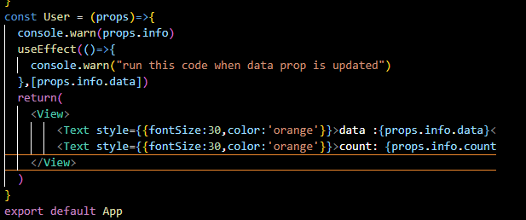

15:15

Now output like below

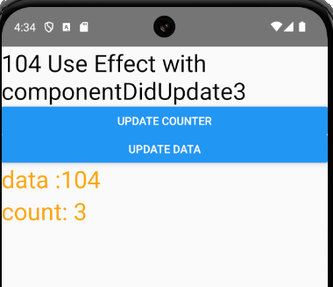

We remove the marked code as marked below

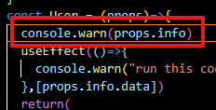

So for now our purpose is as we have our data prop is updated then User useEffect console should run but not on the updation of count state as we have commented useEffect in out App component

Nowe when we click on Update data button then in warning you can see(ATT)



In the warning you can see “run this code when data prop is updated” message in the User component useEffect for data prop Now when we click on Update counter button Now you see the warning will not be given because we had passed data prop in the array of second argument of the useEffect and now we use another useEffect for count prop and in this we set the warning that is similar to data that is “run this code when count prop is updated” as marked below

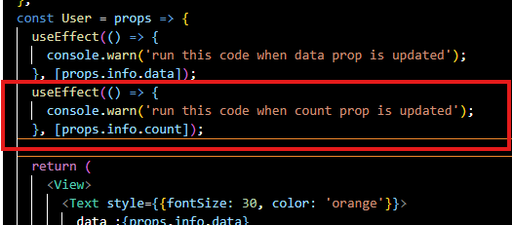

Now this useEffect will be called when the count prop will be updation

Now when we click on the update Counter then you see the warning below(ATT) as marked below

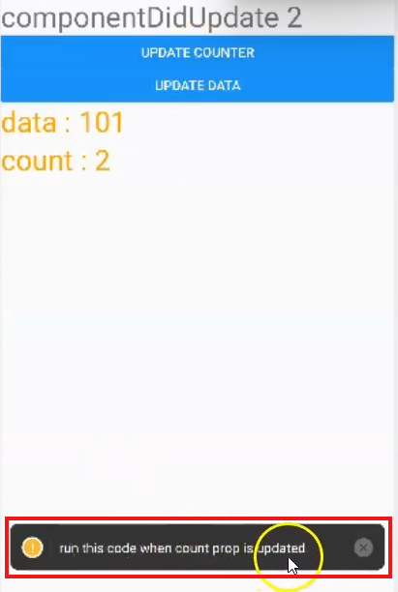

Nad for data below data warning will be shown



So by this you can use useEffect on specific state as well as specific props and you can use more than one useEffect in one component and this is the way that we call using useEffect hook as a componentDidUpdate So that’s all for this lesson.